Group #7

Paridhi Malhotra

Janet Martinez

Preya Patel

**General & Detailed Design**

1. **Define the system of interest**

In this project we will have 3 subsystems. The first subsystem will show the customer how long/ much longer their service will take. The second subsystem will be the database for the entirety of the system. This database will be hosted on the cloud, all this data inside the cloud will be relevant to the system. The third subsystem will be the mobile UI. This mobile application will be developed accordingly to match with iOS or Android systems & settings. This application will allow customers to book and schedule appointments, check on service completion, allow for customer feedback, and show customers the current inventory.

1. **Describe the environment**

In this system we will be using APIs to interact and integrate with other systems. For example, if a customer wants to book a service for their car or make a payment, this will be possible by the API implementation in the system. If a customer wants to speak with an employee, it can be done through an online chat box available in the app via the API implementation. For the security of the app and customers personal information, encryption will be used to keep all data secure.

1. **Design Application Components**

**Component Diagram:**

* **Manufacturing System:** manages the scheduling of the assembly line, quality assurance, production planning, and machine monitoring.
* **Inventory Management:** supervises the quantity of components, raw materials, and completed automobiles in stock at dealerships and production plants.
* **Sales & CRM System:** manages sales statistics, dealer relations, car sales, and customer interactions.
* **Logistics and Supply Chain:** controls the process of delivery, vehicle distribution, and supplier relationships.
* **HR and Payroll System:** handles the preparation of payroll, participation, employee data, and regulatory compliance.
* **Finance and Accounting:** includes spending, inspection, financial reporting, spending, and invoicing.

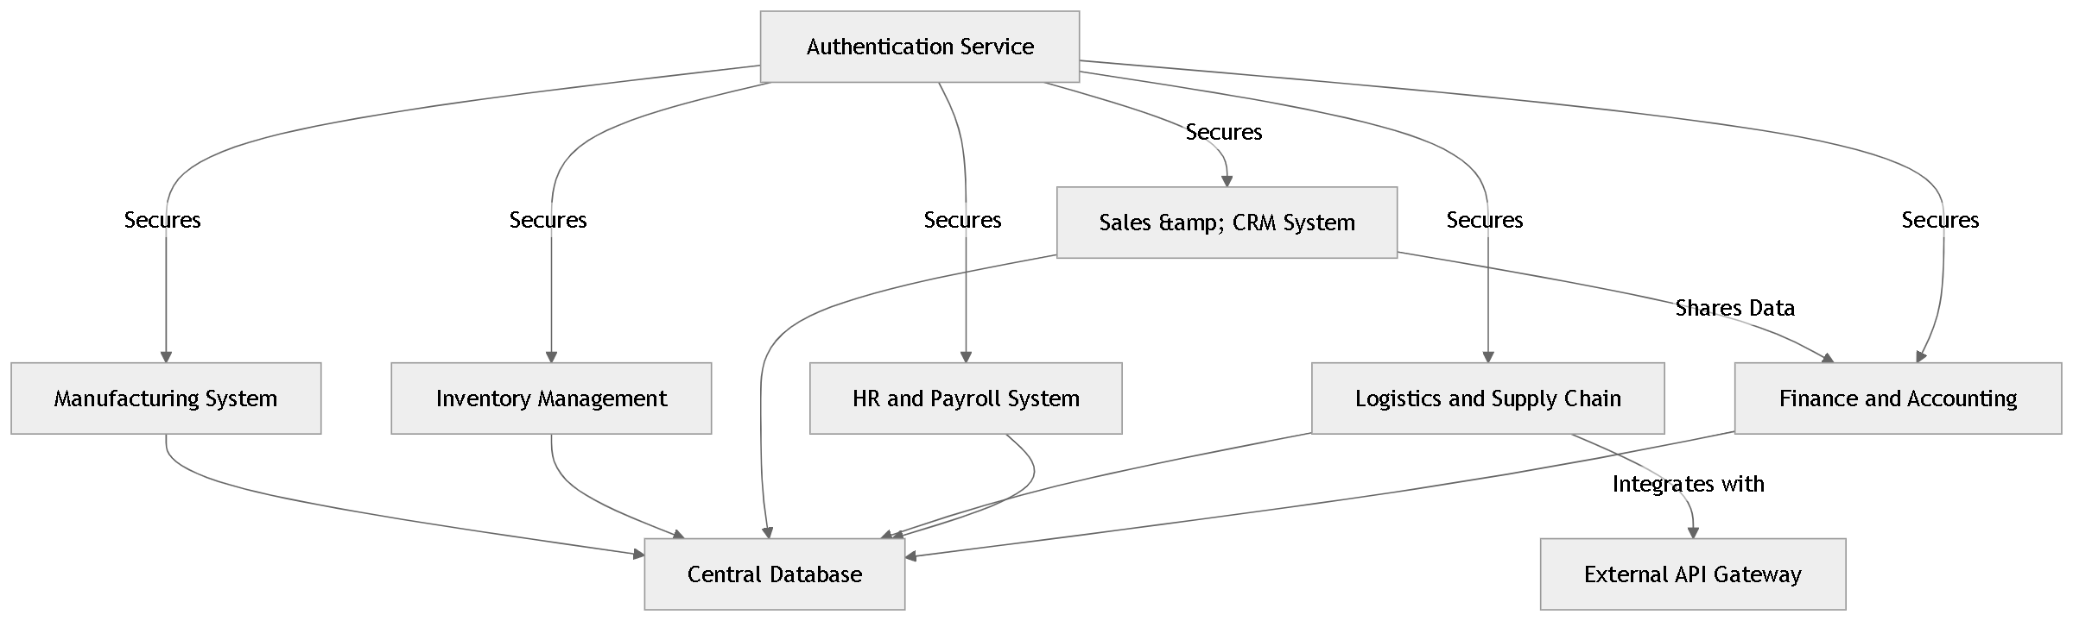

**Package Diagram:**

1. **Manufacturing System Package:**

* Production Planning: Controls the distribution of resources and production schedules.
* Quality Control: Monitors inspections and quality requirements.
* Machine Monitoring: Keeps track of maintenance plans and equipment performance.

1. **Inventory Management Package:**

* Parts Inventory: Manages parts stock and availability.
* Raw Materials: Tracks raw materials used in manufacturing.
* Finished Vehicles: Manages the stock of completed vehicles ready for sale.

1. **Sales & CRM Package:**

* Customer Orders: Handles customer order processing.
* Dealer Management: Manages dealership relationships and orders.
* Sales Analytics: provide information on the buying habits and sales patterns.

1. **Package for Logistics and Supply Chain:**

* Supplier Management: Tracks supplier data and orders.
* Vehicle Distribution: Manages distribution schedules and routes.
* Delivery Tracking: Tracks real-time delivery status.

1. **HR and Payroll Package:**

* Employee Records: Stores employee data.
* Payroll Processing: Processes employee payments.
* Compliance: Manages regulatory and legal compliance.

1. **Finance and Accounting Package:**

* **Invoicing**: Handles sales and purchase invoices.
* **Financial Reporting**: Generates financial reports and audits.
* **Budgeting**: Manages financial planning and budgeting.

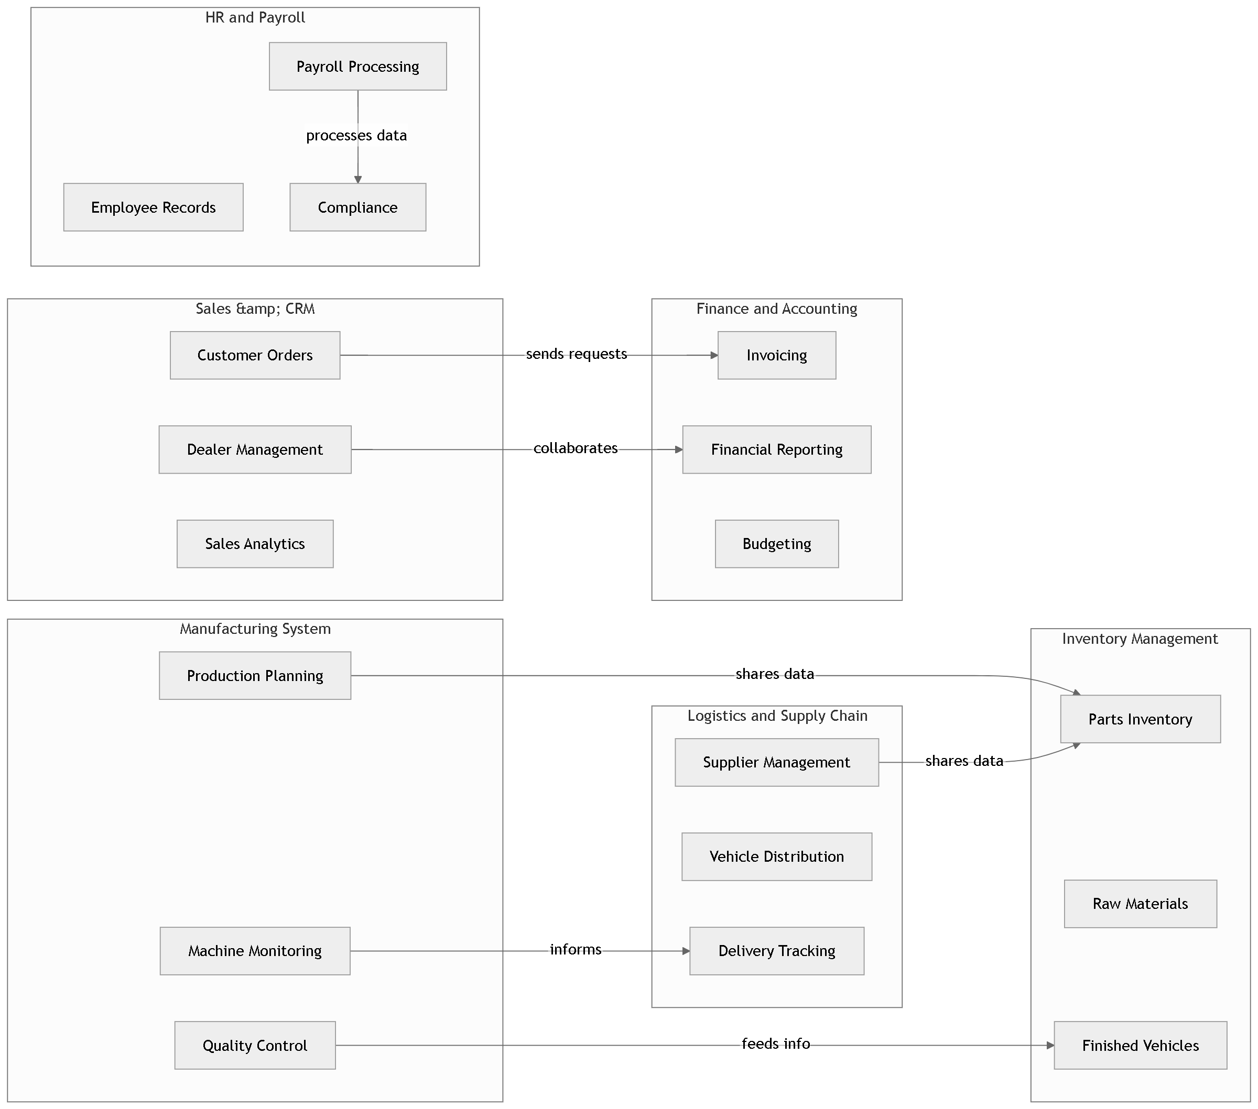

**Deployment Diagram:**

1. **Web Server:** maintains the front end of the program for user access.
2. **Application Server:** houses the business logic for every part (such as sales, inventory, manufacturing, etc.).
3. **Database Server:** holds a central database that all functional components may access.
4. **Mobile Devices:** utilized to remotely view system data by field workers or sales representatives.
5. **Cloud Services:** offers connection with outside third-party services, scalability, and backup.

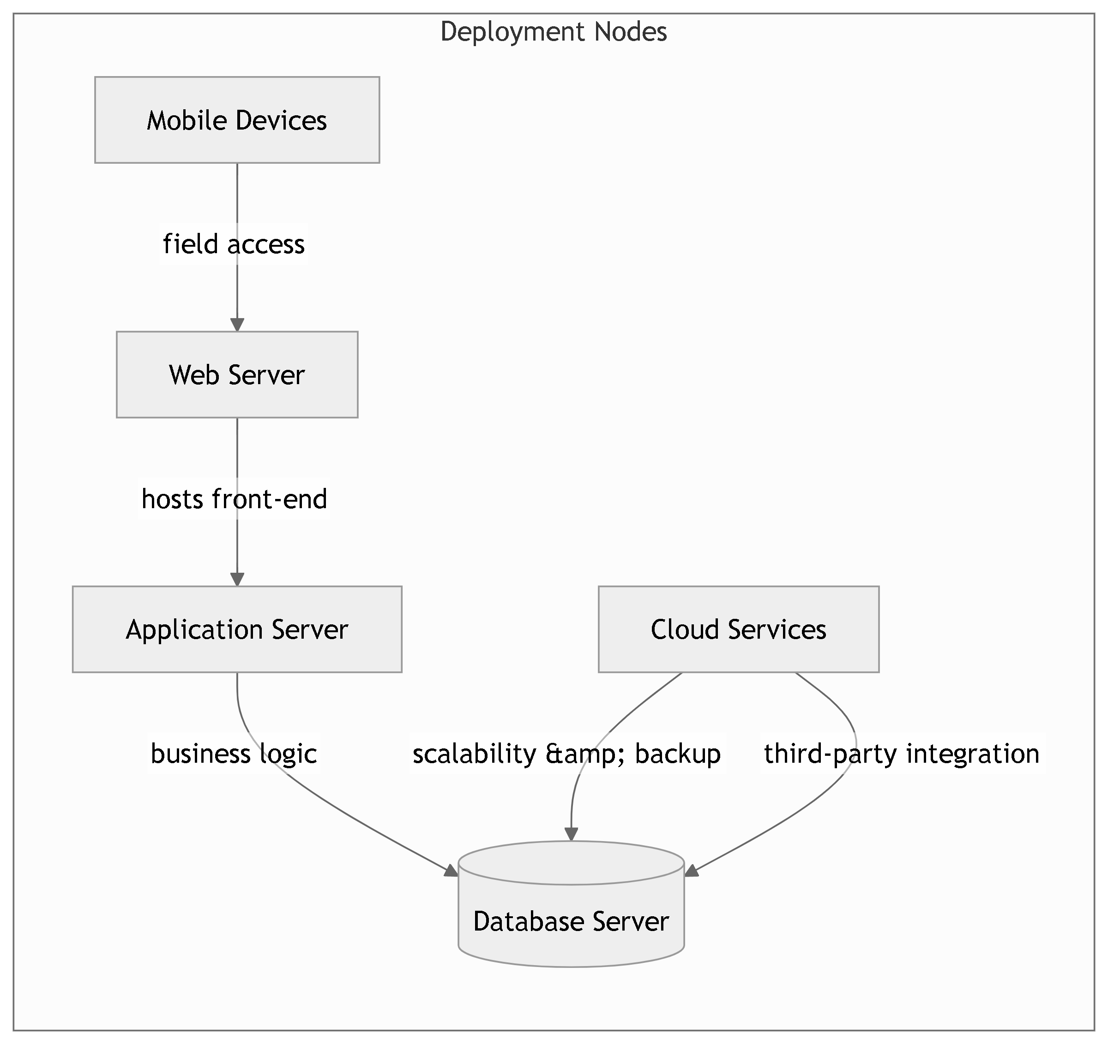

**4. Design the user interface:**

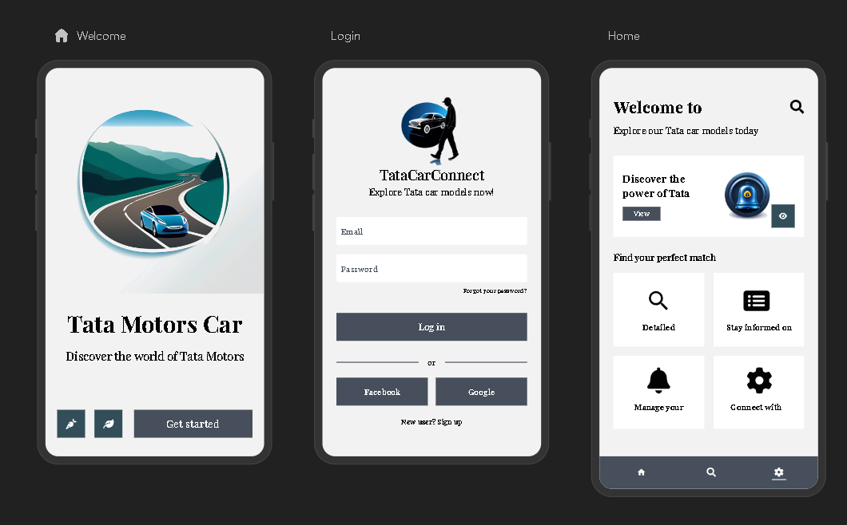

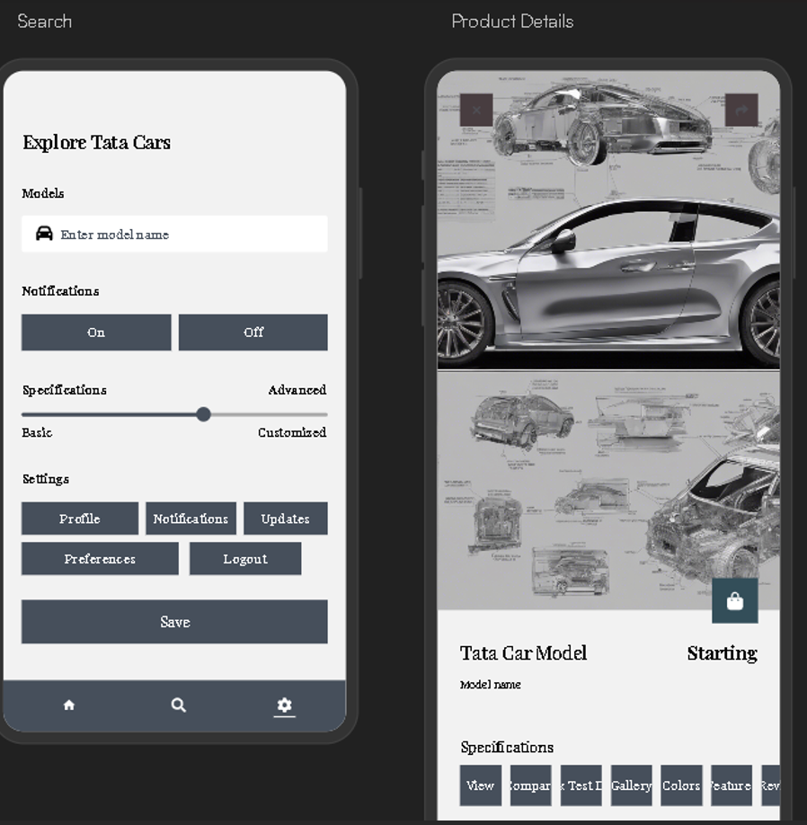

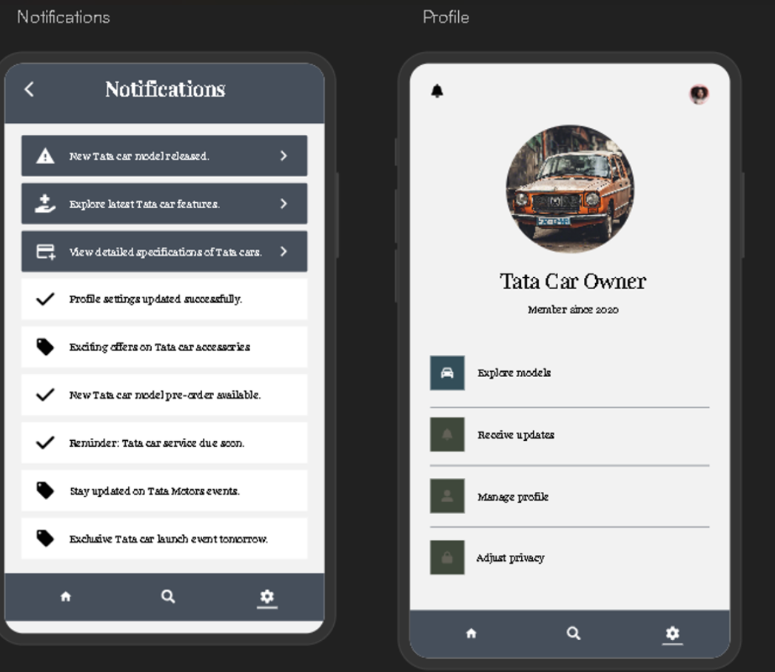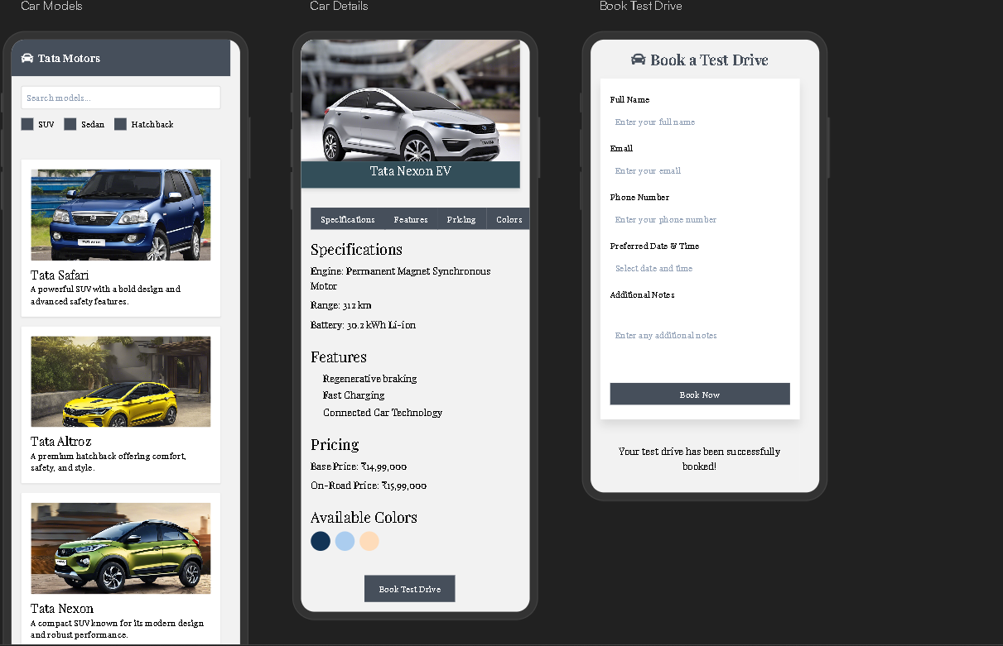

**5.Design the database**

**Description:** This database schema is designed with tables, relationships, and indexes to ensure efficient data management and integrity. Tables include main entities such as Users, Orders, and Products, with foreign key links to maintain data connections. Indexes on key fields enhance search speed and system performance.

1. **Design the software classes & methods**
2. **Class Diagram**

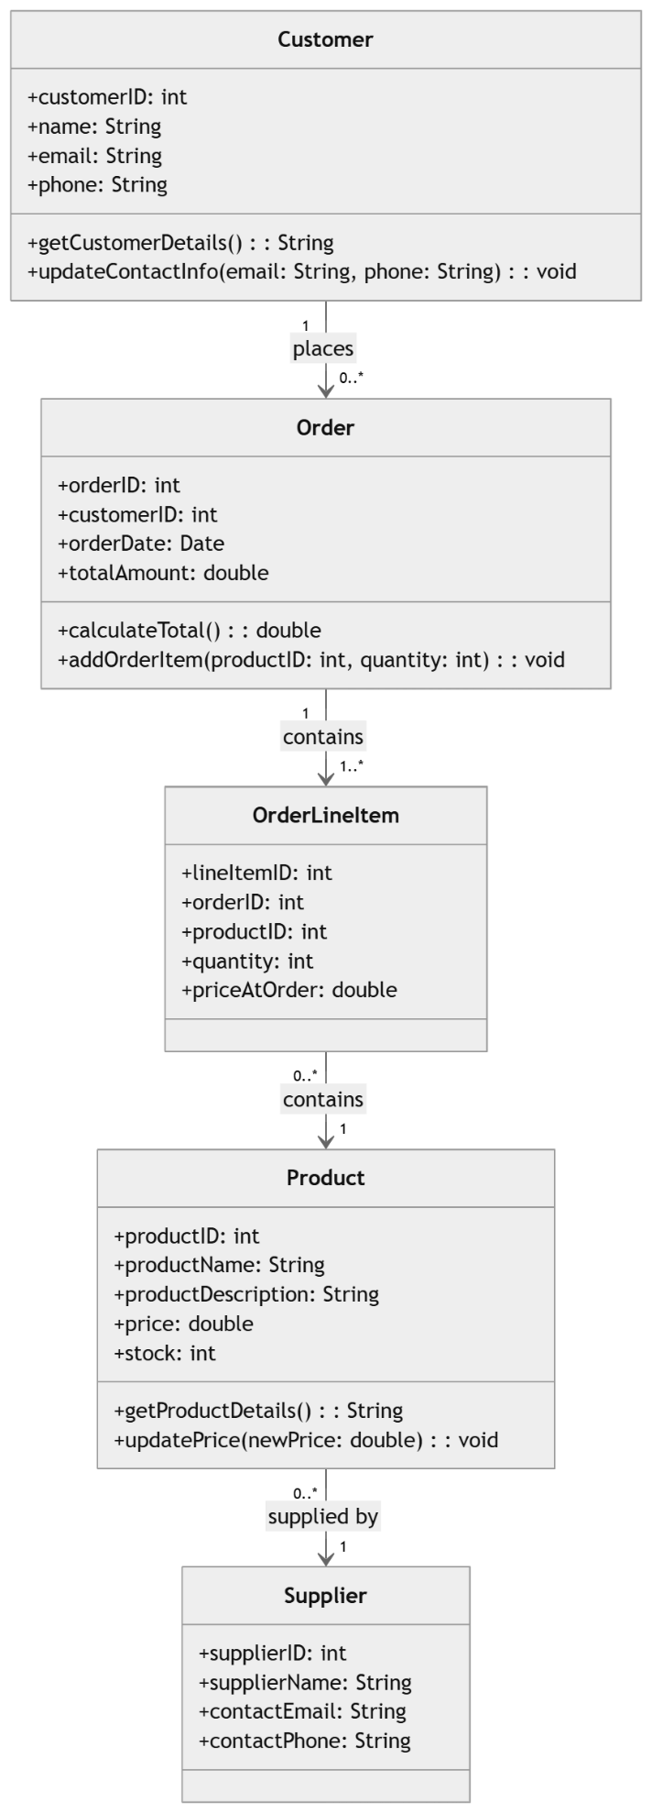

**Description:** This class diagram illustrates the primary classes in the software, including User, Order, and Product. Each class includes relevant attributes and method representing core system components and their relationships. The design promotes modularity and clear data handling across the system.

**B) System Sequence Diagram**

**Description:** The sequence diagram shows interactions between system components for key user actions, such as User interactions with Order processing. It visualizes the message flow and step-by-step execution for major use cases.

**C) State machine Diagram**

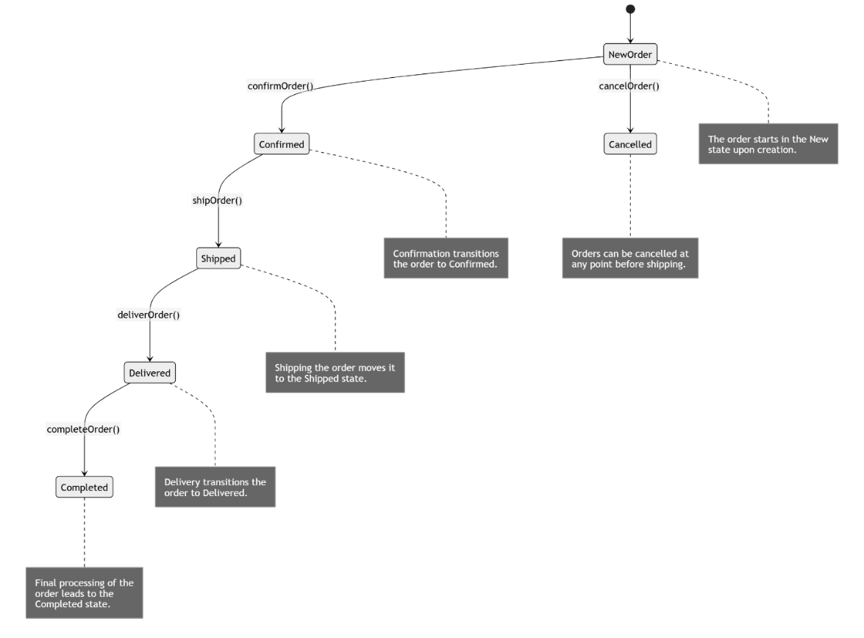

**Description:** The state machine diagram captures lifecycle states of a core entity (e.g., Order), showing transitions like Pending, Processed, and Shipped. State transitions occur in response to actions such as payment confirmation or order shipment.